Last Updated: 3/13/15

**Topic Name:** Hibernate

**Brief Introduction:**

When trying to map basic data to a database we have no problem but what happens when we want to map an object to a database? How do we maintain the relationships that an object has and yet keep all the data in the database separated into nice and neat tables separated by what it is we’re sorting? That is where Hibernate comes in.

One of the main purposes of Hibernate is to allow us to map our Java objects into databases in such a way that we maintain the relationships within our data. In Java object we have things like public and private variables and methods. In databases we have carefully planned out databases that keep and store our data for us in a relational manor through having foreign keys. Again, Hibernate allows us to keep those relationships in tacked by mapping.

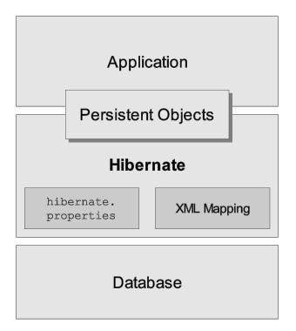

(Image: <http://docs.jboss.org/hibernate/orm/4.3/manual/en-US/html_single/>)

**Teaching Description:**

None yet.

**Teaching Examples:**

None yet.

**Files to View:**

None yet.